July 8, 2024 | Lancaster County Redevelopment Authority – Department of Human Services
FOR IMMEDIATE RELEASE
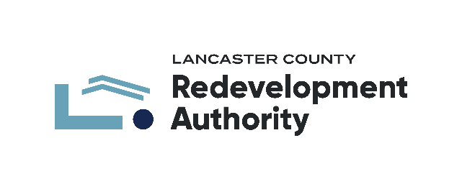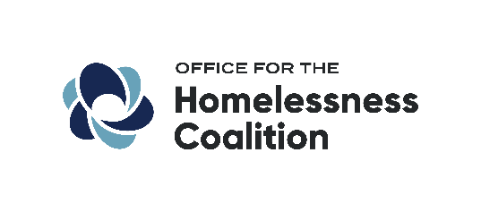
Lancaster County Homelessness Coalition, in partnership with Berks Coalition to End Homelessness and York County Coalition on Homelessness, awarded Youth Homelessness System Improvement Grant by U.S. Department of Housing & Urban Development
In collaboration with the Berks Coalition to End Homelessness and the York County Coalition on Homelessness, the Lancaster County Homelessness Coalition was awarded $990,057 as part of $51.1 million in Youth Homelessness Systems Improvement Grants (YHSI) to 38 communities across 26 states nationwide. Berks County will act as the administrator for the award while the Office for the Lancaster County Homelessness Coalition, as part of the Lancaster County Redevelopment Authority’s Human Services department, will oversee the Youth initiatives and collaboration including hiring a Youth Program Coordinator for the three-county region. Representatives from the tri-county area believe that the opportunity afforded by the YHSI grant for Berks, Lancaster, and York counties to work together to improve the youth homelessness response system is a valuable one. The funding received will strengthen each county’s coalition with a youth voice and perspective, create system mapping and racial and gender equity survey to identify gaps/barriers and develop new resources and connections for youth.
Elise McCauley, Assistant Director of the Berks Coalition to End Homelessness states that, " The Youth Homelessness Systems Improvement (YHSI) grant is a critical investment for Berks County. Our current youth homelessness response system is limited, and we know there are many young people in need who aren't being served. This grant will allow us to finally understand the true scope of the problem by gathering much needed data. With that information, we can develop actionable plans to bridge the gaps and create a truly effective response system for our most vulnerable youth.”
The financial support afforded by the YHSI grant will strengthen the youth homelessness response systems across the tri-county area. Kelly Blechertas, Program Coordinator at the York County Coalition on Homelessness expressed enthusiasm for the opportunity, “As part of a regional grant collaboration with our partners Berks and Lancaster Counties, we are excited to have the opportunity to broaden the scope of our youth systems building, to ensure those youth who are moving between communities can still access the important resources they need. YHSI provides a unique opportunity within federal housing assistance to partner across communities, and we are excited to show the impactful growth that can come from allowing these types of collaborations.”
The YHSI grant program’s focus is on making systemic changes to improve or create response systems for youth at risk of or experiencing homelessness but does not provide funding for direct services or housing for homeless youth. The goal of this tri-county initiative is to address youth homelessness by incorporating the voice of youth with lived experience, mapping of the youth services system across the three counties, and performing a racial and equity analysis of the three counties, strengthening each county’s youth action board.
“This grant is vital because it involves youth in the development of programs and services tailored to their unique needs and compensates them for their valuable contributions. Their insights will shape solutions that bring about positive change for our vulnerable community members.” – Marjorie Shaffer, Homeless Housing Coordinator, who serves as the Youth Homelessness Liaison with the Lancaster County Office for the Homelessness Coalition
The Lancaster County Homelessness Coalition envisions a future with a sustained, safe, and quality home for all who are experiencing or at risk of homelessness in Lancaster County. To learn more about the Lancaster County Homelessness Coalition or to support our work please visit https://lchra.com/our-organizations/homelessness-coalition/.
Media Contact: press@lchra.com

